**Wribbenhall School**

**Spiritual, Moral, Social and Cultural Development Policy**

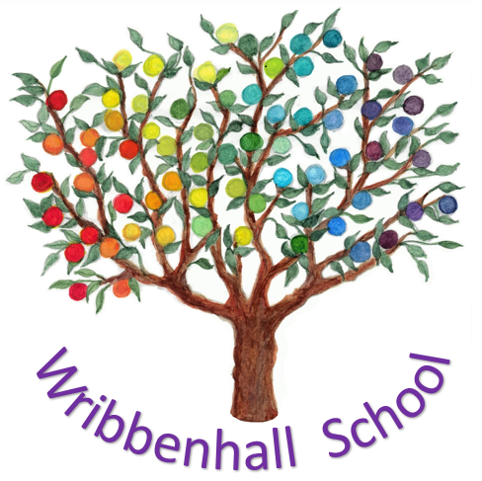

Written: Summer Term 2018

Date of Next review: Autumn Term 2020

**To be read in conjunction with:**

Wribbenhall School Prospectus

Curriculum Policy

**Approved by:**

Proprietor: Ellis Wells

18th August 2018

Spiritual, Moral, Social and Cultural Development Policy

This policy is linked to and derived from the overarching Curriculum Policy. This policy has been reviewed to ensure it does not undermine British Values of Democracy, the rule of law, individual liberty and mutual respect and tolerance of those with different faiths and beliefs.

At Wribbenhall School we recognise that education should not solely be concerned with the development of knowledge and skills but should also encompass the personal development of each young person. We understand that the social, moral, spiritual and cultural development of our students plays a significant part in their ability to learn and achieve and to grow their emotional well-being. Our curriculum focuses on the holistic development of the individual; addressing all of their needs including emotional, physical, relational, intellectual, creative and spiritual. We therefore aim to provide an education that delivers opportunities for the young people to explore and cultivate:

* their own personal values and beliefs;
* spiritual awareness;
* a positive, caring and tolerant attitude towards other people;
* community awareness and a sense of belonging;
* an ability to communicate effectively and interact positively in all social settings;
* an understanding of the way other people will react in social interactions;
* an appreciation of the diversity and richness of cultures, including their own.

We also promote the development of responsibility towards others and the environment. We encourage students to respect specified fundamental British values, including democracy, personal liberty and rule of law.

**Wribbenhall School Values**

At Wribbenhall School we endeavour to support young people during their life journey to develop into self-assured, confident, happy, well-balanced and healthy young people. They are taught to understand and articulate their feelings, whilst being encouraged to have the confidence to ask questions. All students are supported to work towards their own goals and aspirations, all personal achievements are celebrated. Older students are encouraged to support younger students, acting as role-models or peer mentors where possible.

**Social development**

At Wribbenhall School young people are supported to develop their personal, social and communication skills so that they can develop positive relationships with others; interact successfully within the school and wider community; be cooperative and effectively resolve conflict. They are encouraged to develop tolerance and understanding so that they can contribute effectively in a multi-racial, multi-cultural society and develop into positive, helpful human beings.

We teach knowledge and understanding of our society including people, society’s institutions, structures and characteristics, economic and political principles and organisations, roles and responsibilities. We endeavour to prepare our students for life as a citizen, parent, volunteer or worker within the community.

**Moral development**

At Wribbenhall School we support young people to reflect upon their own experiences, enabling them to distinguish the difference between right and wrong, both in themselves and in others, and develop a respect for the civil and criminal law of England. The young people are encouraged to develop an understanding of their own emotions, actions and consequences of their behaviour. They participate in discussions and develop opinions about contemporary moral and ethical issues.

**Spiritual development**

At Wribbenhall School we support young people to be reflective about their own beliefs and perspectives on life. We are inclusive and respectful to all individuals, their faiths, feelings and values. We encourage our students to develop a positive attitude towards themselves, others and the world around them. The curriculum is designed to allow them to use imagination and creativity in their learning.

**Cultural development**

At Wribbenhall School we believe in helping students to develop their understanding and appreciation of the wide range of cultural influences that have shaped their own heritage and that of other communities. We strive to enhance their understanding and respect for diverse faiths and cultures. They are taught about Britain’s democratic parliamentary system and its central role in shaping our history and values, and in continuing to develop Britain. We provide plentiful opportunities for our students to participate in and enjoy artistic, musical, sporting and cultural opportunities.

**Aims**

By providing a nurturing environment along with the delivery of a broad and balanced academic and emotional curriculum we at Wribbenhall School aim to:

* ensure that a student’s education is set within a context that is meaningful and appropriate to their age, aptitude and background;
* empower students to develop their self-knowledge, self- esteem and confidence;
* enable students to distinguish right from wrong and to respect the rule of law;
* encourage students to accept responsibility for their actions and choices, show initiative and understand how they can contribute to community life;
* give each student a range of opportunities to reflect upon and discuss their beliefs, feelings and responses to personal experiences;
* enable students to develop an understanding of their individual and group identity;
* enable students to begin to develop an understanding of their social and cultural environment and an appreciation of the many cultures that now enrich our society;
* give each student the opportunity to explore social and moral issues, and develop a sense of social and moral responsibility;
* encourage students to respect fundamental British values of democracy, the rule of law, individual liberty and mutual respect, and tolerance of those with different faiths and beliefs;
* offer a balanced presentation of opposing viewpoints where political issues are brought to the attention of students;
* offer opportunities to understand the actions of others in social, moral, spiritual and cultural situations.

**Teaching and Organisation of the SMSC Curriculum**

* At Wribbenhall School SMSC will be delivered through virtually all aspects of the school’s broad and balanced curriculum.
* We pride ourselves on the nurturing ethos at Wribbenhall School. We promote teaching styles which value students’ questions and encourage reflection, thoughts, ideas and concerns.
* We create an environment where opportunities are accessible to all, enabling each young person to recognise and achieve their potential.
* We provide opportunities for SMSC development outside of the classroom i.e. visits to Wyre Forest, museums, historic buildings, through exploration of art and the sciences.
* We will develop personalised timetables in collaboration with our learners to ensure their engagement and motivation for learning.
* We provide opportunities for students to participate in fund raising work to support local charities.
* Our students participate in regular relaxation/ therapeutic activities to explore ways of understanding and dealing with their emotions.
* Hold regular events to develop and deepen cultural awareness.
* Welcome guest speakers from within our community to give an insight into roles, responsibilities and career opportunities, speakers include Police, Fire Service, Paramedics.
* Provide SEAL /Nurture/ Circle time sessions.
* Encourage students to talk about personal experiences and feelings and learn to effectively express and clarify their own ideas and beliefs. To include speaking about difficult events, e.g. bullying, death etc.
* Explore relationships with friends/family/others.
* Develop empathy.
* Develop the skills and attitudes that enable pupils to develop socially, morally, spiritually and culturally – e.g. empathy, respect, open mindedness, sensitivity, critical awareness, etc.
* When we encounter partisan views, whilst in and out of the school (while they are in attendance at the school, or while they are taking part in extra-curricular activities) we take such steps (discussion of different view points, democratic methods of debate) as are reasonably practicable to ensure that where political issues are brought to the attention of pupils they are offered a balanced presentation of opposing views.

Many curriculum areas provide opportunities to:

* listen and talk to each other;
* learn an awareness of treating all as equals, and accepting people who are physically or mentally different;
* agree and disagree and learn to deal appropriately with conflict;
* take turns and share equipment;
* work co-operatively and collaboratively.